ES



**Pre-Lab 2**

Name: Socheath Sok,

Class: EE 346 L

Section 6, T/Th

Date: September 11, 2018

**Part A**

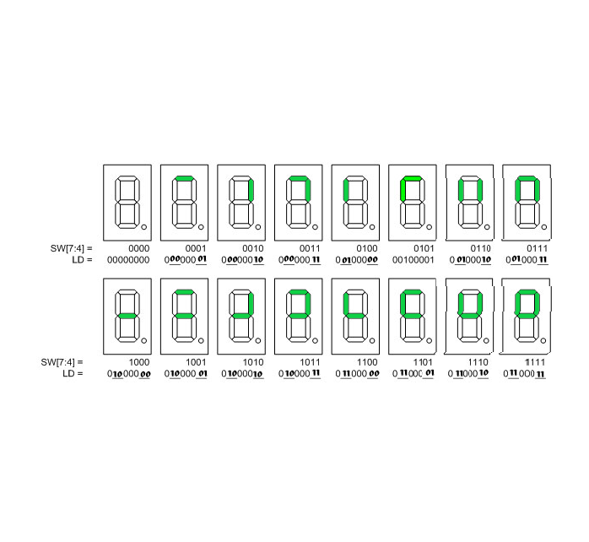

***Assembly Instructions for Wiring Switches to the 4 Segments***

call ReadSwitches  
bst r6,7 // wire switch 7 to segment g (south wall)  
bld r7,6

bst r6, 6 //wire switch 6 to segment f (west wall)

bld r7, 5

bst r6, 5 //wire switch 5 to segment b (east wall)

bld r7, 1

bst r5, 4 //wire switch 4 to segment a (north wall)

bld r7, 0  
call WriteDisplay

**Part B**

***Boolean Logic***

*South*: **LDg**  → 00

*East*: **LDb** → 01

*West*:  **LDf** → 10

*North*: **LDa** → 11

***Flowchart***

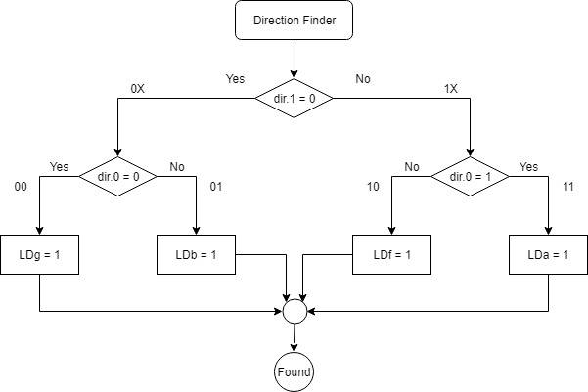

**Part C**

***Question***

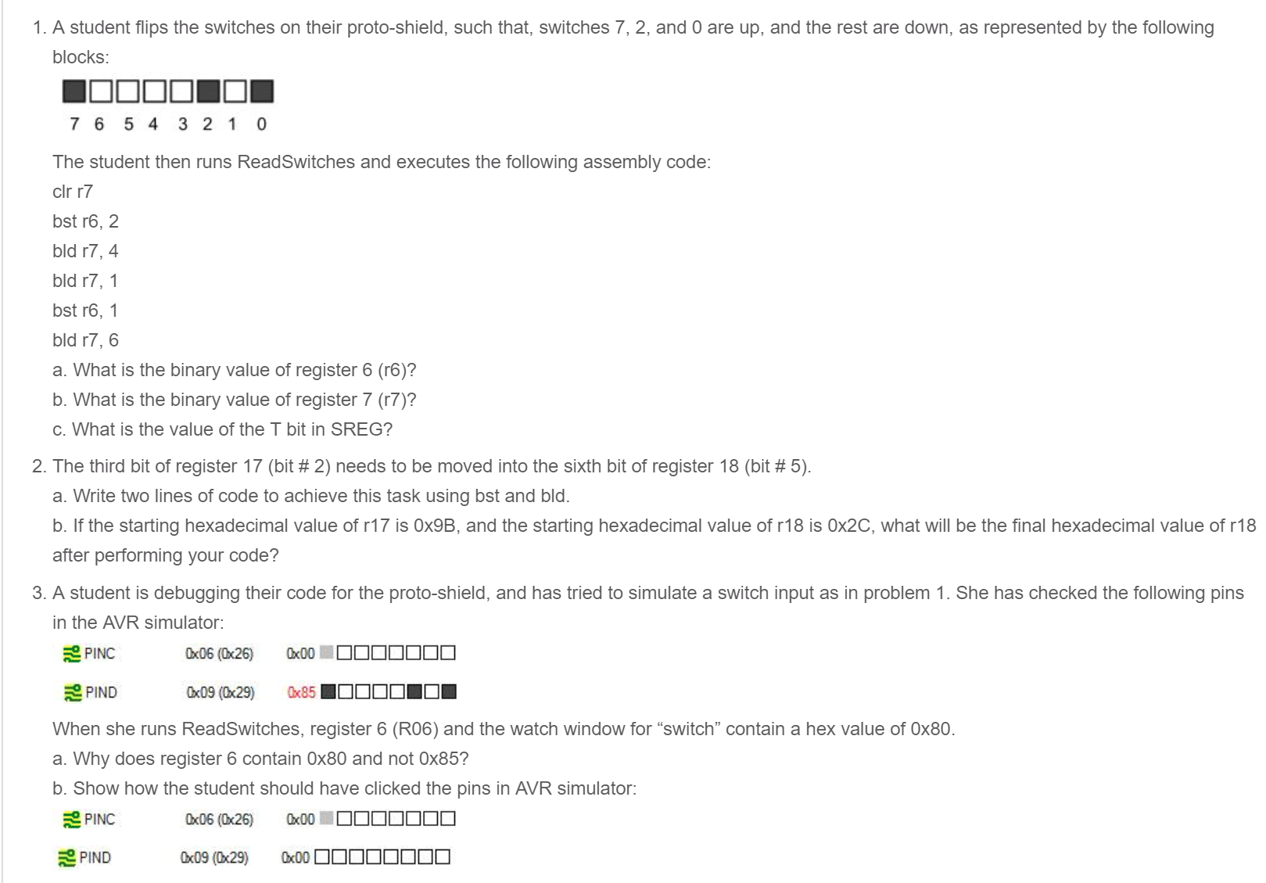

***Answer***

1. A. The binary value of register 6 (r6) is 0

B. the binary value of register 7 (r7) is initially 0001 0000 before changing to 0001 0010.

C. the value of the T bit in SREG is initially 2 before changing to 1.

2. A. bst r17, 2

bld r18, 5

B. Given r17 = 1001 1**0**11 and r18 = 00**1**0 1100, the final hexadecimal value of r18 is

0X0C (0000 1100).

3. A. The code produced the wrong result because she checked the wrong pins.

B. The correct answer for 0x85 is:

